/*Question 1: Reaction*/

DATA REACTION;
INPUT STIM TIME @@;
DATALINES;
1 1.94 1 1.94 1 2.92 1 2.92 1 2.92 1 2.92 1 3.27
1 3.27 1 3.27 1 3.27 1 3.70 1 3.70 1 3.74
2 3.27 2 3.27 2 3.27 2 3.70 2 3.70 2 3.74
;
RUN;
ODS HTML;

PROC PRINT DATA = REACTION;
RUN;
ODS HTML CLOSE;

Question 1.1
ODS HTML;
ODS GRAPHICS ON;
PROC NPAR1WAY DATA = REACTION WILCOXON;√
TITLE "COMPARE TWO INDEPENDENT GROUPS";√
CLASS STIM; √
VAR TIME; √
EXACT; √
RUN;
ODS GRAPHICS OFF;
ODS HTML;

Question 1.2

TITLE "COMPARE TWO INDEPENDENT GROUPS";

Question 1.3

Ho: The two types of stimulants have the same distribution of reaction times (In minutes). 1√2
Ha: The two types of stimulants do not have the same distribution of reaction times (In minutes).1√2
Conclusion: The Two sided p –value is 0.1054, √ suggesting that the two groups have the same distribution (They come from the same population). The two types of stimulants that the subjects were under produces the same distribution of reaction times (In mInutes) √
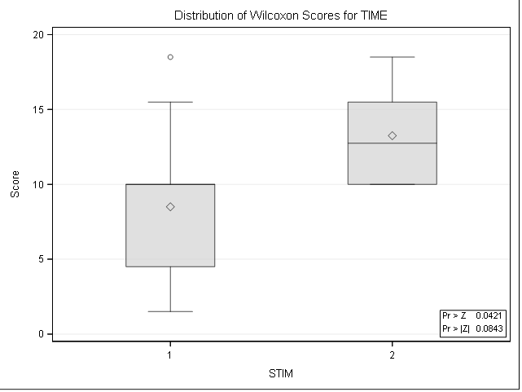√√
/*Question 2: Hypnosis*/

DATA HYPNOSIS;
length EMOTION $ 10;
INPUT SUBJECT EMOTION $ SKINRESPONSE @@;
DATALINES;
1 fear 23.1 1 joy 22.7 1 sadness 22.5 1 calmness 22.6
2 fear 57.6 2 joy 53.2 2 sadness 53.7 2 calmness 53.1
3 fear 10.5 3 joy 9.7 3 sadness 10.8 3 calmness 8.3
4 fear 23.6 4 joy 19.6 4 sadness 21.1 4 calmness 21.6
5 fear 11.9 5 joy 13.8 5 sadness 13.7 5 calmness 13.3
6 fear 54.6 6 joy 47.1 6 sadness 39.2 6 calmness 37.0
7 fear 21.0 7 joy 13.6 7 sadness 13.7 7 calmness 14.8
8 fear 20.3 8 joy 23.6 8 sadness 16.3 8 calmness 14.8
;
RUN;

ODS HTML;
PROC PRINT DATA = HYPNOSIS;
RUN;
ODS HTML CLOSE;

Question 2.1

Libname sas_proj “location for library”;
Run;

Proc import out = sas_proj.skin_data
Datafile = “location_dataset.csv”
Dbms = csv replace;
Getnames = yes;
Run;

Question 2.1
ODS HTML;
ODS GRAPHICS ON;
PROC FREQ DATA = HYPNOSIS; √
TABLES SUBJECT*EMOTION*SKINRESPONSE√ / CMH2√ SCORES=RANK√ NOPRINT; √
RUN;
ODS GRAPHICS OFF;
ODS HTML CLOSE;

Summary Statistics for EMOTION by SKINRESPONSE
Controlling for SUBJECT

Cochran-Mantel-Haenszel Statistics (Based on Rank Scores)
Statistic | Alternative Hypothesis | DF | Value | Prob
1 | Nonzero Correlation | 1 | 0.2400 | 0.6242
2 | Row Mean Scores Differ | 3 | 6.4500 | 0.0917
√
Total Sample Size = 32

Question 2.2
Ho: The distribution are the same across the repeated emotions. √
Ha: There are some differences in distributions across the repeated emotions. √
Friedmans test
Conclusion: The Friedman’s chi-square is 6.4500√ with 3 degrees of freedom and the p-value is 0.0917. Because the p-value is more than 0.05, one would conclude that the distributions are the same across the repeated emotions. √

